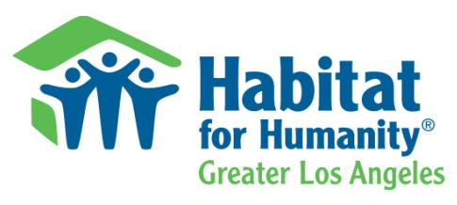

Speaker Request Form
Thank you for your interest in learning about Habitat for Humanity of Greater Los Angeles. Please fill out this form and email it to Speakersbureau@habitatla.org or fax it to (310) 324-9736.
Contact Information:
Primary Contact Person:
Title: First Name: Last Name:
Email Address:

Phone: Alternative Phone:
Fax:

Organization/Group Information:

Name:

Street: City: State: Zip code:
Website:

Event Information:

Event Name:

Event Group/Sponsor:

Event Location:
Street: City: State: Zip code:
Event Purpose:

Number of attendees expected:

Audience Demographic: If other, please describe:

Other services provided: If other, please describe:

Presentation Information:

Length of Speech (in minutes): 3-5 6-10 11-15

16-20 21-30 30+

Requested speech topic:

Presentation method:

Requested Speaker:

If preferred speaker is unavailable, will you accept another speaker: Yes No

Will there be Q & A after the speech? Yes No

Can audio/visual equipment be provided? Yes No If yes, please describe:

Is a bio needed for speaker introductions: Yes No

Would you like us to send a copy of the PowerPoint or handouts in advance? Yes No

Other comments:

